
The Mixed Nuts
2016 Party Set
Cindi Meyer
01-J07-Give Me A Kiss To Build A Dream On(KVF).2014.11.29.pdf
02-J16-Birth Of The Blues(KVF).2016.02.07.pdf
03-J06-You're Just In Love(KVD).2016.01.25.pdf
Jenny Aguirre
04-A13-Someone To Watch Over Me (KVM).pdf
05-C10-They Can't Take That Away From Me(KVM).2015.01.01.pdf
06-C09-Come Fly With Me(KVM).pdf
Katrina Nelson
07-B15-Unforgettable(KVF).2014.10.19.pdf
08-C15-Fly Me To The Moon(KVF).2015.02.08.pdf
09-AA05-At Last(KVF).2015.02.08.pdf
Kristie Arnold
10-AA15-Dream A Little Dream Of Me(KVF).2014.02.10.pdf
11-B13-My Funny Valentine(KVF).2014.03.14.pdf
12-DD16-Sway(KVM).2016.04.10.pdf
Robyn Gomez
13-R02-I Only Have Eyes For You(KVM).2016.06.05.pdf
14-S12-Sentimental Journey(KVF).2014.01.23.pdf
15-S01-It's A Good Day(KVF).2015.10.27.pdf
Wendy White
16-DD10-Bewitched(KVF).2015.07.19.pdf
17-U05-Chances Are(KVF).2016.04.24.pdf
18-D01-Alright, OK, You Win(KVF).2016.04.24.pdf
Katie Blunt
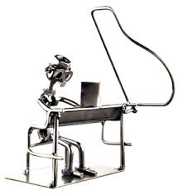
19-N06-All I Do Is Dream Of You(KVF).2015.01.25.pdf

20-CTRY08-I'm Walkin' The Floor Over You(KV).2016.07.17.pdf
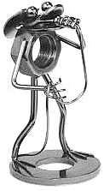
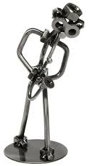

21-P17-Shoo Fly Pie(KVF).2015.01.25.pdf

